**المحاضرة الرابعة**



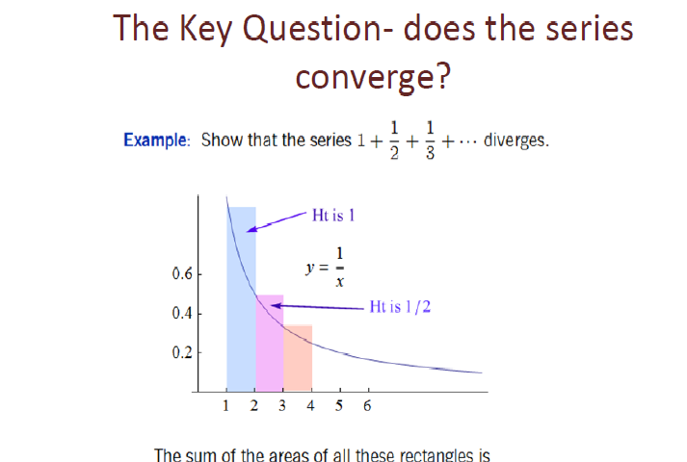





The area under the curve *y = 1/x* is less than the sum of areas of rectangles



**The integral Test**





Note that if n is raised to a high enough power, the series will converge.



